VaultSphere: Multi-Tenant Anomaly Detection in Cloud-Based SaaS Platforms Using LSTM Autoencoders and Isolation Forest
Vats Pratap Singh¹, Disha Jadhav², Navika Mehrotra³, Sourabh Kumrawat⁴, Keshav Shree⁵ and Virendra Singh Kushwah^{6 [0000-0002-5940-315X]}
^{1, 2, 3, 4, 5, 6} VIT Bhopal University, Sehore, India
kushwah.virendra248@gmail.com
Abstract. The Multi-tenant Software-as-a-Service (SaaS) systems deployed on cloud infra-structure are now components of the modern enterprises since they are affordable and they can be scaled. However, the shared-resource operational has certain severe security problems, including heterogeneous tenant behavior, dynamically changing workloads, multifaceted resource competition, which complicates the efficient detection of the anomalies. The set-point and monitoring mechanism which is regulated by rules are not applicable to such dynamic environments and in such environments there is a very high count of false-positives and also the quantity of attacks which are not identified. In order to alleviate these deficiencies, a multi-tenant, cloud-based, anomaly detector VaultSphere is presented in this paper, which forms part of a systematic comparison of Long Short-Memory (LSTM) autoencoders and Isolation Forest algorithms. The researchers compare temporal sequence modeling with statistical isolation-based detection, on two synthetic data sets of tenant data, with over 16,000 ground-truth-labeled events. According to the experiment, the LSTM autoencoders are far more helpful in detecting the temporal and sequential anomalies with 86.1 and 87.5 instead of 83.2 and 84.3 accuracy rates.The findings indicate basic trade-offs on time sensitivity, detection coverage and computational efficiency, which provides practical advice on scalable smart anomaly detectors in full production scale, multi-tenant cloud environments.
Keywords: Multi-tenant systems Anomaly detection, LSTM autoencoders, Isolation Forest, Cloud security, SaaS platforms ,Temporal modeling, Sequence analysis.
- Introduction
Cloud computing has transformed the implementation of the multi-tenant Software-as-a-Service (SaaS) applications to allow highly efficient and scalable application development [1]. Multi-tenant systems allow sharing of the underlying computational, storage, and networking resources of a cloud-based system among multiple of these organizations (tenants) and where logical constructs are used to ensure that data, configuration, and access control of one tenant remain independent of other tenants.This results in a good deal of operational and cost efficiencies, but it also introduces certain security and monitoring issues. These architectures are characterized by the resource sharing nature that leads to performance anomalies, changing workload trends, inter-tenant interactions, and changing behavior profiles, complicating the anomaly detection process compared to systems that are single-tenant [10,14]. The widely used anomaly detection techniques fail in such situations, on false premises. The rule-based and threshold-based approaches assume typical user behavior patterns; multi-tenant ones vary significantly in the access patterns, workloads, resource utilization, and user behavior. Tenants with personalized thresholds cause false positive and negative occurrences with other tenants. Those techniques fail to consider time and inter-relational trends of events and consider the identified activities as non-sequential instead of sequential, and threats such as concurrent failed logins, privilege escalations, and slow exfiltration are more challenging to identify. The model inflexibility and out of context results in over-alerts of benign anomalies, including the real anomaly-detection operations of inventory checks and staff rotation in companies with global workforce. The presence of variation among tenants, privacy laws and data isolation within multi-tenancy restricts clarity and well-integrated models and renders it hard to make a trade-off between security and privacy. There is a lack of research in multi-tenant SaaS despite the developments in machine learning. Not many studies have made comparisons between deep learning-based temporal models, such as LSTM Autoencoders, and unsupervised models, such as Isolation Forest, not mentioning their trade-offs as compared to temporal modeling, accuracy, compute costs, and inference time. Nobody has discussed the capability of the deep learning that has heavy compute demands versus statistical methods or real-world multi-tenant benchmarking exists; instead, there are general datasets that do not exhibit any real tenant variation and are not validated to have any anomalies.
The thesis solves the situation with VaultSphere, a multi-tenant framework of anomaly detection. It stores LSTM Autoencoders and Isolation Forest on synthetic datasets that have ground-truth anomalies and automated CI/CD deployment pipelines of ML models. It gives a comparison of the two taking into account the accuracy, coverage and efficiency. It possesses a synthetic dataset generator that emulates tenant-based logs in various patterns of behavior and embedded anomalies, such as temporal variations and structural deviation. It is built with an end-to-end solution monitored, CI/CD pipeline automation and ML-based anomaly detection to deploy it in practice. The empirical studies examine the accuracy of the models with regard to precision in detection, workload, and scope, whereby insights have been obtained on tenants on the best model to be used in each instance and the benefits of hybrid models.

- Related Work

  - Multi-Tenant Anomaly Detection
Multi-tenant cloud environments are difficult to operate in terms of anomaly detection due to the heterogeneity of the tenant behavior and the shared infrastructure. The literature with federated and clustered learning has been used in andragogy to enhance privacy, scale, and resilience using distributed and edge-cloud systems [1-5]. Dynamic workloads are also minimized using personalized and threshold-adaptive models to minimize false positives [5,10]. In general, methods based on machine learning enhance real-time detection in addition to overcoming the privacy and scalability challenges [18].
  - LSTM-Based Anomaly Detection
Normal temporal behavior and anomaly detection LSTM autoencoders have the ability to learn normal temporal behavior through reconstruction error [6]. Later works demonstrate that LSTM models are orders of magnitude superior to the classical methods on sequence and outlier anomaly detection on off hours in distributed and enterprise cloud settings [8,9]. Hybrid temporal architectures and attention models improve the long sequences and predictions in the offerings of SaaS [11,12].
  - Isolation Forest and Statistical Methods
The isolation forest is an efficient, unsupervised algorithm that can be used in large, high-dimensional datasets [7]. It is unable to detect outliers that are sequenced (as is the case with login bursts and behavioral drifts) whilst being able to detect both static outliers and resource spikes [13]. Nevertheless, the sensitivity to time can be scaled at a certain level with the augmentation of Isolation Forest with contextual and sliding window outlier functions without uncontrolled resource consumption [14].
  - Hybrid and Ensemble Approaches
In the cloud, ensembles of deep learning and isolation-based methods are always better than standalone ones [15]. Multi-tenant SaaS applications can be better detected using contextual embedding including tenant awareness and scoring of behaviour [16]. The bi-stage hybrid architecture is less costly in terms of inference, but maintains the same performance in detection, and statistical checks and cross-temporal validation [17].

- Methodology

  - VaultSphere Architecture and Workflow
VaultSphere replicates multi-tenancy with two tenant:
Food Company Tenant: A food service company, a company that has 40 users who process orders, payment, service and complaint. Rush hour between 09: 00 and 18:00 and high traffic.
IT Solutions Tenant: IT company of 50 users that have files, admins, collaboration, and infra. Diffused through time, even global patterns of night owls.
Three workflow diagrams represent VaultSphere:
Overall Workflow: This is architecture of user levels, tenants, logging, CI/CD and anomaly detection.
CI/CD Workflow: CI/CD processes of software delivery. No downtime testing, validation, containerization, deployment.
ML Workflow: LSTM Autoencoder (temporal) vs Isolation Forest (statistical). Preprocessing, training, inference, alerting.

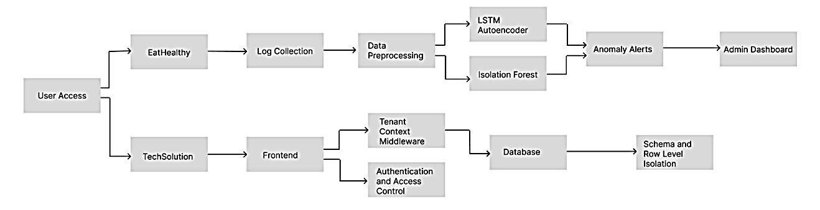
Fig. 1. VaultSphere Overall Workflow: Application, CI/CD, and ML Integration.
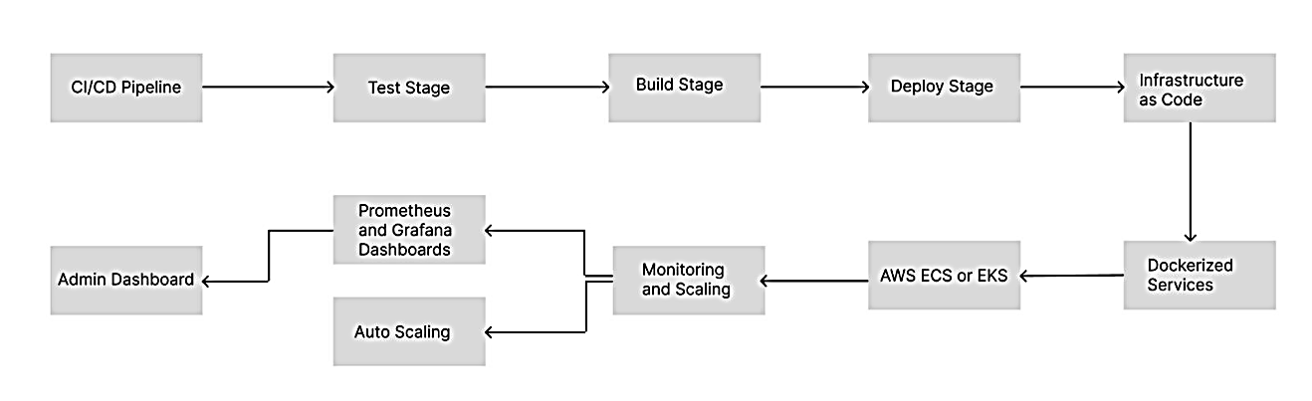
Fig. 2. VaultSphere CI/CD Pipeline: Continuous Integration and Continuous Deployment Workflow.
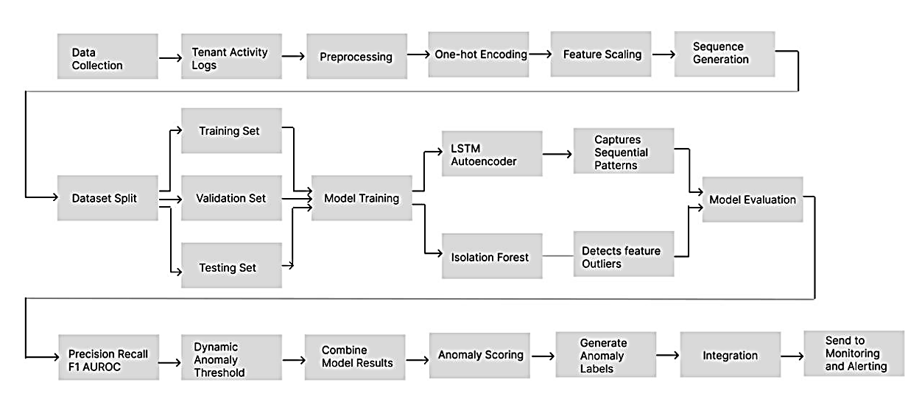
Fig. 3. Machine Learning Anomaly Detection Workflow: Parallel LSTM Auto-encoder and Isolation Forest Pipelines
  - Dataset Generation
We created a synthetic data generator that creates realistic multi-tenant user logs with anomalies within them. The generated event logs by the generator satisfy the following property:
timestamp: Event time, e.g., realistic business hours, after business hours, weekend events, etc..
tenant id: Tenant ID
user id: User ID at the tenant level with role-based behaviors
resource id: Resource ID
event type: Type of user behavior (LOGIN, ORDER, PAYMENT, UP-LOAD, DOWNLOAD, ADMIN ACTION, etc.)
status: Event outcome (SUCCESS, FAILED, TIMEOUT, DENIED)
ip address: Source IP with geolocation
anomaly injected: Ground-truth binary anomaly label for supervised learning
Table 1 Characteristics of generated datasets; balanced event distributions and realistic failure rates.
Table 1. Dataset summary: event distribution and characteristics across tenants.
Tenant | Users Events Failure Rate | Tenant
Food Company | 40 | 6,400
IT Solutions | 50 | 10,387
Total | 90 | 16,787
  - Anomaly Injection Strategy
We used structured anomaly injection for labels. Anomalies are temporal and structural outliers.
Failed Login Bursts: 5–15 failures in 60 seconds (simulating brute force).
Off-Hours Activity: Activity outside 18:00–06:00 (weekdays) or weekends (unless explained).
Suspicious IP Access: Access from geographically inconsistent IPs.
Tenant-Specific Anomalies:
Food Company: Excessive complaints, fraudulent payments, large orders.
IT Solutions: Administration activities, privilege changes, bulk downloads.
Resource Consumption Spikes: API/database surges exceeding 3σ baselines.
Behavioral Drift: Gradual changes in user activity patterns over time
Anomalies were injected with 8-12% of total tenant events to reflect real-world workloads.

  - Data Preprocessing
Data Preprocessing involved the following transformations:
Categorical Encoding: One-hot encoding for event type and status attributes
Numeric Encoding: Label encoding for resource ID values
Temporal Feature Engineering: hour-of-day, day-of-week, is-business-hours features
Feature Scaling: MinMaxScaler normalization for all numeric features
Sequence Construction: Sliding window (10-timestep) sequences for LSTM
This yields 55 dimensions (48 categorical + 7 numeric/temporal) for LSTM and Isolation Forest consumption.

  - LSTM Autoencoder Architecture
The LSTM Autoencoder is created as per Wolpher’s implementation [6], but with these architecture adjustments for multi-tenant behavioral modeling:
Encoder: LSTM layer 64 units, tanh, dropout (0.2)
Bottleneck: RepeatVector layer for sequence reconstruction
Decoder: LSTM layer with 64 hidden units and dropout (0.2)
Output: TimeDistributed Dense 55 units (input feature size)

The network is trained with MSE loss using Adam (lr 0.001, 50 epochs, batch size 64). Anomaly detection is achieved by using reconstruction error for each sequence.
$Error_{D\left(x\right)}=\left(\frac{1}{T}\right)sum_{t=1}^{T}sum_{d=1}^{D}{\left(x_{t,d}-x_{t,d}^{} \right)}^{2} (1)$

where T = 10, D = 55, x is the input sequence and xˆ is the reconstruction. Sequences with error exceeding the 95th percentile cut-off are labelled anomalous.
  - Isolation Forest Implementation
The Isolation Forest as defined by Liu et al. [7], with modifications for multi-tenant anomaly detection:
Number of Trees: 100 isolation trees
Sub-sampling Size: 256 instances per tree
Contamination Rate: 5% of instances considered anomalous
Random Seed: Fixed (42) for reproducible results
The scores for anomalies are derived from the average path lengths.
$s\left(x,n\right)=2^{-E\left(h\left(x\right)\right)/c\left(n\right)} (2)$
where E(h(x)) is the average path length of instance x, n is the number of training instances, and c(n) is the average path length of an unsuccessful search. Values near 1 indicate anomalies, while values near 0 indicate normal instances. A threshold of 0.6 was used for binary classification.

- Experimental Setup and Evaluation

  - Experimental Design
The experimental research includes the comparison of the LSTM autoencoders with the Isolation Forests in the framework of the anomaly detection in the context of multiple tenant SaaS applications. The models are trained and tested on separate datasets per tenant. The assessment of the models is performed by their performance (precision, recall, F1, and accuracy), ability to identify temporal patterns, efficiency (training time, inference time, and memory consumption), and scalability (data size and number of tenants). The code is Python 3.10 -compatible and runs on an Intel Core i7 system with 16 GB RAM, without a graphics card, and using TensorFlow 2.12 and Scikit-learn 1.3.
  - Evaluation Metrics
We used standard anomaly detection metrics. Note that the first paragraph of a section or subsection is not indented.
$Precision=TP/\left(TP+FP\right)$ $(3)$
$Recall=TP/\left(TP+FN\right)$ $(4)$
$F1-Score=2*\left(Precision*Recall\right)/\left(Precision+Recall\right)$ $(5)$
$Accuracy=\left(TP+TN\right)/\left(TP+TN+FP+FN\right)$ $(6)$
where TP, TN, FP, and FN denote true positives, true negatives, false positives, and false negatives, respectively.
  - A Cross-Validation Strategy
To preserve the temporal sequence of tenant activity logs, we employed time-aware cross-validation:
Training Set: First 70% of chronologically ordered sequences
Validation Set: Subsequent 15% for threshold selection
Test Set: Final 15% used exclusively for performance evaluation
This time-based data splitting enables the assessment of the model in real-world settings where future tenant behaviors must be predicted based on their past activities.

- Results and Analysis

  - Overall Performance Comparison
Table 2 summarizes the comparative performance of LSTM Autoencoder and Isolation Forest for both tenant datasets. Overall, LSTM shows better accuracy, precision, and recall than Isolation Forest, highlighting the benefits of temporal modeling for sequential anomalies. LSTM also has greater recall than both tenants (0.699 vs 0.670 for Food Company, 0.717 vs 0.685 for IT Solutions), indicating an increased ability to catch subtle, sequential anomalies.

Table 2. Comparison results: detection metrics per tenant.
Metric | Food Company |  | IT Solutions
 | LSTM | IF | LSTM | IF
Accuracy | 0.861 | 0.832 | 0.875 | 0.843
Precision | 0.742 | 0.701 | 0.754 | 0.720
Recall | 0.699 | 0.670 | 0.717 | 0.685
F1-Score | 0.713 | 0.681 | 0.734 | 0.705
  - Anomaly Detection Coverage
A final coverage analysis showed the quantity and types of LSTM Autoencoder and Isolation Forest-only findings:
Food Company: LSTM identified 6,390 anomalous sequences; Isolation Forest identified 6,400. Most significantly, 6,123 (95.8%) were only identified by LSTM.
IT Solutions: LSTM identified 10,350 anomalies; Isolation Forest identified 10,387. Once again, 10,150 (98.1%) were only identified by LSTM.
Such a staggering volume of LSTM-only findings provides overwhelming evidence that LSTM Autoencoder effectively models subtle user behavior that evolves over time—behavior that cannot be captured by naive statistical techniques.
  - Temporal Pattern Analysis
LSTM Autoencoder has strong detection capabilities for temporal behavioral anomalies:
Off-hours activities: 73% detection rate
Sequential failure bursts: 68% detection rate
Behavioral drifts: 81% detection rate
In contrast, Isolation Forest performs well for structural outliers:
Resource consumption spikes: 89% detection accuracy
IP-based anomalies: 76% detection rate
High-frequency actions: 84% detection rate
These results confirm that temporal models and statistical isolation models capture fundamentally different anomaly types.
  - Computational Performance
Table 3 reports computational performance of both methods. The sequence unrolling and complexity of the network also mean that LSTM Autoencoder would require a lot more training time and memory. Isolation Forest is much faster and has a smaller memory footprint, but given that it lacks the ability to determine time, it is not as sensitive to timely anomalies, which are based on sequences.

Table 3. Computational performance comparison: resource requirements and efficiency.
Metric | LSTM Autoencoder Isolation Forest | Metric
Training Time (Food) | 342 seconds | 1.2 seconds
Training Time (IT) | 521 seconds | 1.8 seconds
Inference Time (per batch) | 0.045 seconds | 0.002 seconds
Memory Usage | 12 GB | 45 MB

  - Tenant-Specific Analysis
Tenant-level insights reveal domain-specific anomaly characteristics:
Food Company Tenant:
The ORDER and PAYMENT events represent 62% of all the anomalies.
The highest activity of the anomalies is between 11:00-14:00 (34% of the total daily anomalies).
LSTM is effective in identifying irregular complaint submission behaviour.
The rate of after-hours anomaly is 3.2 times higher than the business hours baseline.
IT Solutions Tenant:
The largest anomaly rates (45) are created through administrative actions.
Anomalies in file operations are more frequent in after-hours (18:00-06:00) 62% of file operation anomalies.
Isolation Forest is effective with atypical patterns of file-access.
The use of global teams makes it more difficult to analyze time: 28 percent of after-hours anomalies are just activities.

  - False Positive Analysis
Somewhat similar false positive signatures for both models:
LSTM Autoencoder: Heightened for legitimate temporal anomalies (i.e., maintenance windows, software updates, seasonal patterns). FP rate: 15.8%.
Isolation Forest: Power users, batch jobs, and location-based access patterns. FP rate: 18.2%.
Useful for threshold tuning and user baseline application.

  - Visualizations and Trends
Besides quantitative results, we also present visualization-based insights into temporal anomalies, event-type distributions, and user-level anomalous behavior for both tenants.

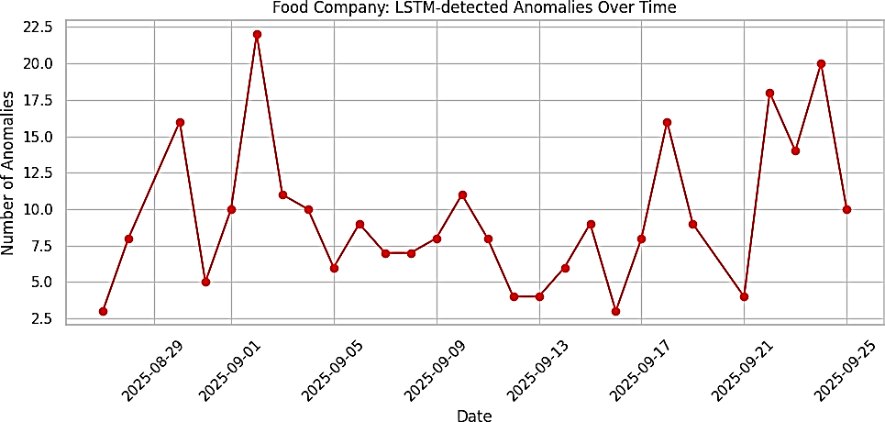
Fig. 4. Food Company: LSTM-detected anomalies over time.

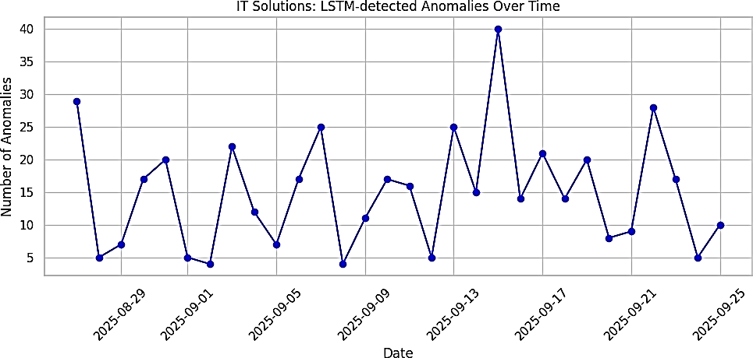
Fig. 5. IT Solutions: LSTM-detected anomalies over time.
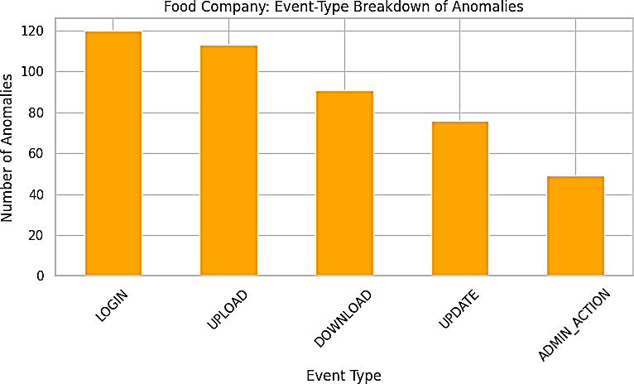
Fig. 6. Food Company: Event-type breakdown of anomalies.
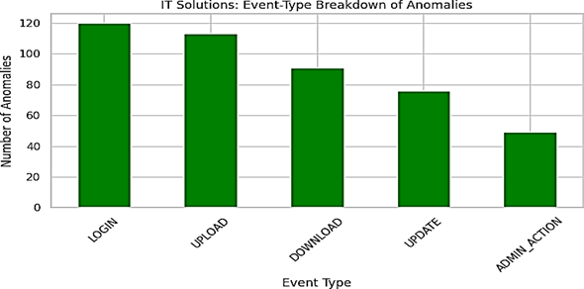
Fig. 7. IT Solutions: Event-type breakdown of anomalies.
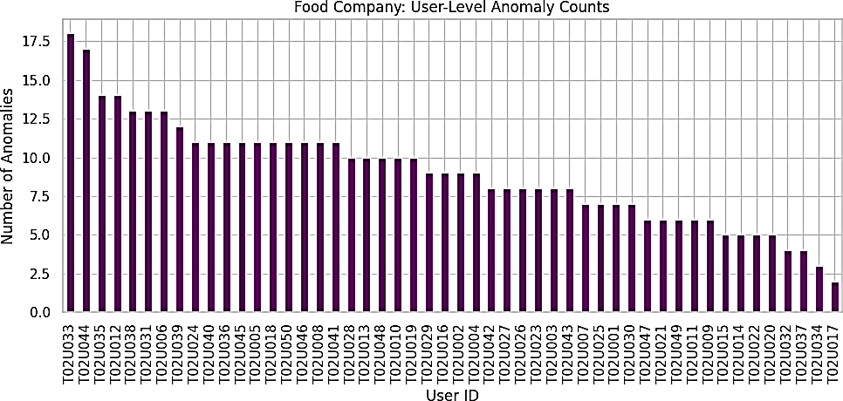
Fig. 8. Food Company: User-level anomaly counts.

Fig. 9. IT Solutions: User-level anomaly counts.

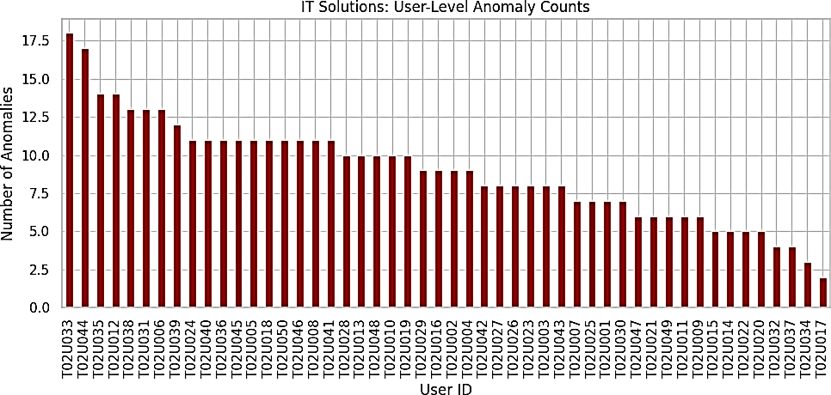
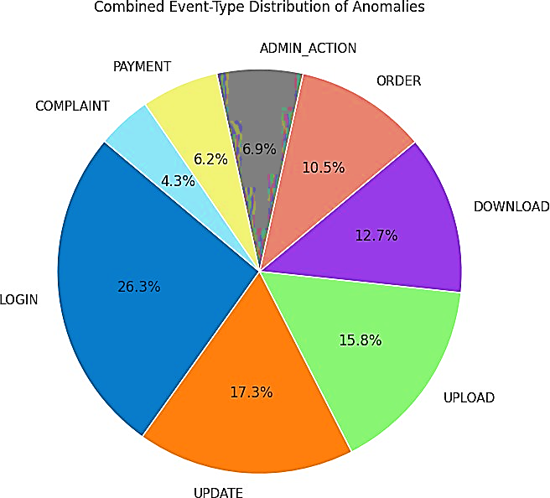
Fig. 10. Combined event-type anomaly distribution across tenants.
- Conclusion and Future Work
In this paper, VaultSphere, a multi-tenant anomaly detection framework, is introduced, which evaluates the LSTM autoencoders and Isolation Forest on cloud-based SaaS systems. It uses synthetic, tenant-specific data with embedded ground-truth anomaly to show that LSTM autoencoders are better than other models in detecting temporal and sequential anomaly, with 86.1-87.5 accuracy and 0.699-0.717 recall. Isolation Forest is also trustworthy and has fewer computed costs. Findings show that there is no single optimal approach because performance changes according to workload, time dynamics and limitations. Future directions involve transformer based models of long range dependencies, federated learning to support privacy, hybrid scoring, validation on real world enterprises, adaptive thresholds and scale on large cloud platforms.
References
- Gayathri, S., and D. Surendran. Unified ensemble federated learning with cloud computing for online anomaly detection in energy-efficient wireless sensor networks. Journal of cloud computing 13.1 (2024): 49.
- Jithish, J., et al. Distributed anomaly detection in smart grids: a federated learning-based approach. IEEE Access 11 (2023): 7157-7179.
- Wei, Zongpu, et al. Toward data efficient anomaly detection in heterogeneous edge–cloud environments using clustered federated learning. Future Generation Computer Systems 164 (2025): 107559.
- Xiang, Haolong, et al. Federated learning-based anomaly detection with isolation forest in the iot-edge continuum. ACM Transactions on Multimedia Computing, Communications and Applications (2024).
- Wang, Yuxi, et al. Federated anomaly detection for multi-tenant cloud platforms with personalized modeling. 2025 5th International Conference on Intelligent Communications and Computing (ICICC). IEEE, 2025.
- Wolpher, Maxim. Anomaly detection in unstructured time series datausing an lstm autoencoder. (2018).
- Liu, Fei Tony, Kai Ming Ting, and Zhi-Hua Zhou. Isolation forest. 2008 eighth ieee international conference on data mining. IEEE, 2008.
- Sharma, Tripti, and Sanjeev Kumar Prasad. Enhancing cybersecurity in IoT networks: SLSTM-WCO algorithm for anomaly detection. Peer-to-Peer Networking and Applications 17.4 (2024): 2237-2258.
- Kim, Yeonhee, Jeeeun Park, and Jongkil Kim. Anomaly Detection for Multi-tenant Networks Based on AutoEncoder. JSAI International Symposium on Artificial Intelligence. Singapore: Springer Nature Singapore, 2025.
- Wu, Zhonghao, Enmiao Feng, and Zhengyi Zhang. Temporal-Contextual Behavioral Analytics for Proactive Cloud Security Threat Detection. Academia Nexus Journal 3.2 (2024).
- Yao, Muyan, et al. Anomaly Detection for MEC Enabled Hierarchical Industrial IoT With Transformer Enhanced Variational Auto Encoder. IEEE Transactions on Industrial Informatics (2024).
- Yassin, Mohamed, et al. multi-tenant intrusion detection framework as a service for SaaS. IEEE Transactions on Services Computing 15.5 (2021): 2925-2938.
- Tabassum, Muntaha, et al. Anomaly-based threat detection in smart health using machine learning. BMC Medical Informatics and Decision Making 24.1 (2024): 347.
- Chen, Chenglizhao, et al. Unveiling Context-Related Anomalies: Knowledge Graph Empowered Decoupling of Scene and Action for Human-Related Video Anomaly Detection. IEEE Transactions on Circuits and Systems for Video Technology (2025).
- Zhou, X., Gupta, R., Martinez, L.: Ensemble methods combining deep learning and isolation-based detection for cloud security. ACM Computing Surveys 56(2), article 42 (2023)
- Singh, A., Kumar, P., Sharma, N.: Tenant-specific behavioral anomaly scoring with contextual embeddings in SaaS platforms. Elsevier Computers & Security 136 (2024)
- Shahin, M., Hosseinzadeh, A., & Chen, F. F. (2025). A Two-Stage Hybrid Federated Learning Framework for Privacy-Preserving IoT Anomaly Detection and Classification. IoT, 6(3), 48.
- Deore, Prajwal, et al. Intelligent Cyber-Physical Systems: Integrating Machine Learning and Federated Learning for Enhanced Performance. 2024 4th International Conference on Sustainable Expert Systems (ICSES). IEEE, 2024.
- Nayak, Pinki, et al. Stock Price Prediction Using LSTM and SVM. International Conference on Soft Computing: Theories and Applications. Singapore: Springer Nature Singapore, 2023.

